A New Approach to Farming
BY
Frances L. Chandler, O.B.E., Ph.D

Having experienced significant changes in weather patterns and in fact just come through the driest “wet season” on record, it should be obvious to farmers and indeed the population in general, that we must think much more seriously about water and adapt our agriculture and horticulture to a more restricted/uncertain supply of this resource. As Meena Palaniappan, a senior research associate and project director at the Pacific Institute, a research group in Oakland, California notes “Unless a water main erupts, people don't think about water. It's easy to ignore, because right now you can turn on your tap."
But water supply shortages are becoming a problem of global proportion. In the past month, 2,000 farmers in India were arrested for stealing water; the regional government of Catalonia in Spain said it was going to import water by boat and train beginning in May to provide summer supplies; the Queensland Water Commission in Australia put local residents on the toughest water restrictions; and in Atlanta, residents filed lawsuits against the municipal government in protest over faulty water pipes and failing sewer systems .
According to the World Water Institute, a mere 2.5 percent of the earth's ground and surface water is accessible for human use. This finite resource, maintained by the earth's hydrologic cycle, is used for everything from drinking water to sanitation, agriculture and industrial processes. Undermined by overuse, pollution and inefficient infrastructure as well as natural occurrences like drought, humankind's water supply is nearing its limit.( http://www.nytimes.com/2008/04/25).
Of course there are a number of technologies available to supplement fresh water supplies, like desalination , reclaiming wastewater and so on, but these are expensive , so farmers should do their utmost to harvest rainwater and to use technologies which reduce the water requirement on their farms.
In horticulture, in the landscaping business and in home gardens, serious thought will have to be given to using drought resistant plants in attractive garden designs, known as xeriscapes i.e landscaping and gardening that reduces or eliminates the need for supplemental water from irrigation. One such garden in St Peter was shown by the Barbados Horticultural Society this year.
More trees with dense canopies may also have to be used to shade garden beds and thus reduce water loss due to evaporation. Tall windbreaks are to be recommended to protect plants from severe winds which increase evaporation of water from plants and soil.
Choice of plants is important. Plants with leaves which are waxy, succulent, hairy, sticky, small, needle-like, or silver in colour are usually drought resistant. Some examples of tropical drought resistant ornamentals are; dracaena, cordyline, oleander, jatropha, agave, euphorbia(e.g Song of Jamaica) , oyster plant, Rhoeo spathacea, Pittosporum, plumbago, bougainvillea, schefflera, allamanda, powder puff plant, portulaca, silver dollar, aloe, vinca , desert rose and of course cactus. Those attending the Barbados Horticultural Society’s recent annual flower show would have seen the very attractive display of cacti and succulents. The landscaping on the “Life of Barbados roundabout” is a good example of what can be done with drought resistant plants.
As far as agricultural crops are concerned, ability to survive under drought conditions is one of the many reasons for retaining sugar cane in Barbados. Very few crops other than sugar cane could withstand drought under the very shallow soil conditions in Barbados. Although growth and yield would be affected , plants seldom die, and recovery is evident after a few showers of rain. Sugar cane also ratoons, so that the soil surface does not have to be exposed for about 3 to 4 years. Use of strip tillage in sugar cane is also another way of minimizing loss of soil moisture from fields.
We may have to consider other drought tolerant crops like sorghum, especially in the driest areas like St Philip and St Lucy. Sorghum has been well researched under local conditions, so there would be a base of information to build on. It would also be a good choice, seeing that we import considerable quantities of animal feed ingredients.
Aloe is also another possibility. There is some experience growing aloe commercially in Tobago and Aruba, where there is a processing plant producing skin care products for export.
But, as Ministry of Agriculture entomologist Ian Gibbs notes, these drought resistant crops do attract specific pests, so proper control measures have to be put in place.
In both food crop and ornamental farming, improving the water holding capacity of the soil by adding organic matter like well - rotted animal manure and/or compost is highly recommended. Mulching of soil also reduces evaporation of soil moisture by covering the soil surface. Sugar cane produces its own mulch (trash) which is in fact one of the characteristics which makes it attractive for our soils.
In vegetable production, the use of plastic mulches which can be mechanically laid is also another option. This is already being used, but may have to be introduced on a larger scale. There is however, a risk of nematode buildup under the plastic as has been observed in the past.
In ornamental gardens, gravel, pebbles and wood chips also make an attractive soil covering to reduce water loss from soils.
The benefits of collecting rainwater are well known. This has been done for many years at Redland Plantation in St George. The surface water from roads etc is led by drains into a fabric lined pond . Fish are kept in the pond to prevent mosquito breeding. This water is best used via drip irrigation.
Timing of irrigation is also important. Watering before the heat of the day sets in is recommended. This also gives the crop time to dry off before night fall, reducing the likelihood of fungal diseases developing on the foliage.

The use of overhead irrigation is very wasteful, especially under our windy conditions. Using drip irrigation where the water is applied to the spot where it is to be used, will not only conserve water, but will reduce weed growth.

Hydroponics is also a way to reduce water use, especially if it is a recirculating system.

There are a number of water retaining products on the market. These reduce the quantity of water required for irrigation, ,since they retain moisture in the soil for an extended period. Some of these products have been tried locally with positive observations made.

There is also a variety of growth boosters coming on the market. These help plants to germinate quickly and to establish strong root systems so that they are better able to stand up to drought. Less frequent, heavier irrigations also encourage plants to establish deep root systems , while frequent light irrigations encourage the plant roots to grow near the surface where they are more vulnerable to drought.
If farmers can harvest water off farm buildings to water their livestock and collect surface water to irrigate crops, the potable water from the BWU can be freed up to be used for drinking, cooking and other essential uses.

As usual, the best approach to any situation is to be proactive and to take corrective steps before the situation becomes critical.

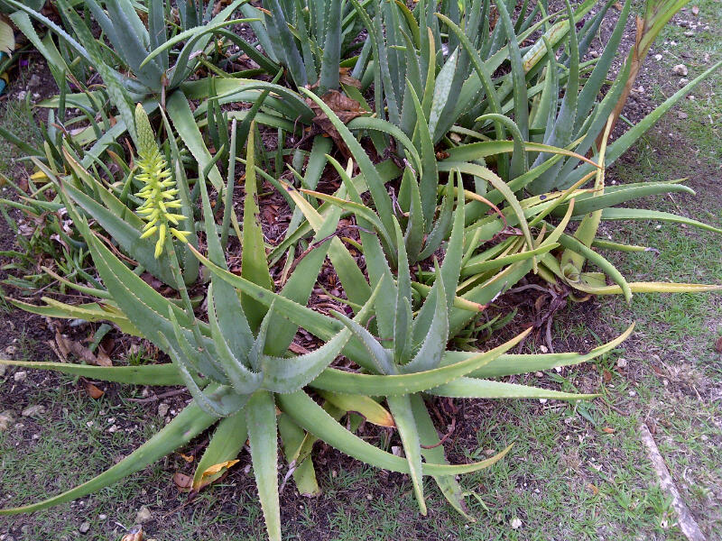
Aloe

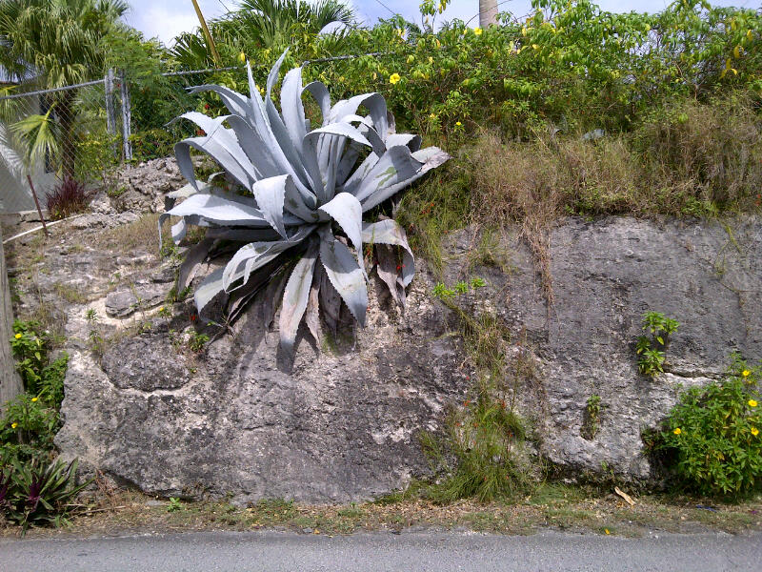
Agave

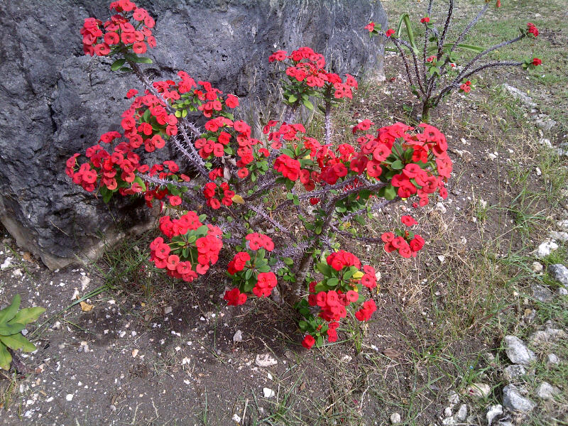
Crown of Thorns

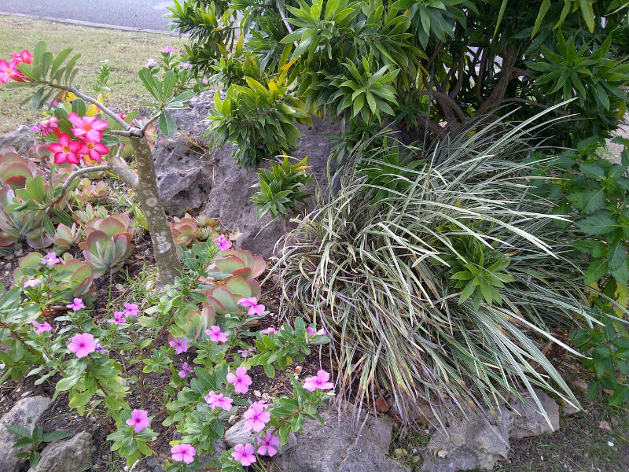
Vinca, succulents, desert rose and song of Jamaica- all drought tolerant

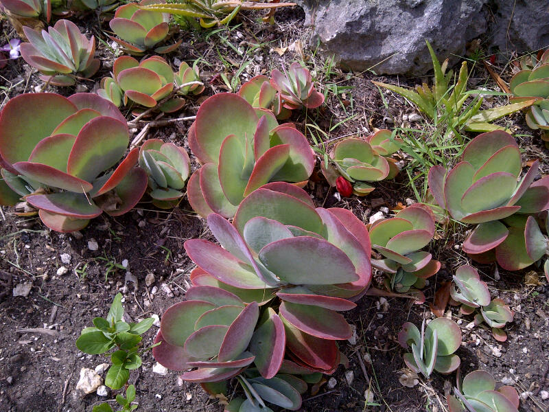
Succulents
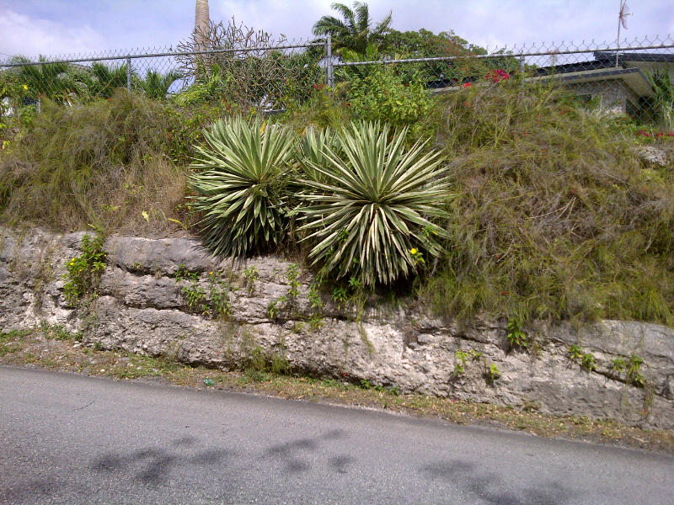
Agave

